**ST.PAUL’S UNIVERSITY**

**NAIROBI CAMPUS**

**REGULAR/DAY PROGRAM**

**FACULTY OF BUSINESS, COMMUNICATION, INFORMATION TECHNOLOGY**

**DEPARTMENT OF INFORMATION AND COMPUTER SCIENCE**

**BCS 2107: DATABASE SYSTEMS 1**

**DATABASE PROJECT: ARTIFICIAL INTELLIGENCE RUN TEXT BOOK DISTRIBUTION SYSTEM**

**ADM. NO. BSC/NRB/5789/22**

**SUBMITTED TO: Mrs. Cecilia Nanfuka**

**SUBMISSION DATE: MARCH 30 2023**

**INTRODUCTION**

The Artificial Intelligence run Text Book distribution system for a primary school is a database system designed to manage the distribution of textbooks to students and teachers in a primary school. The system is designed to store information about students, teachers, textbooks, and the distribution, and make it easy for school administrators to manage the distribution of textbooks.

**ER DIAGRAM**

The ER diagram for the database is shown below:

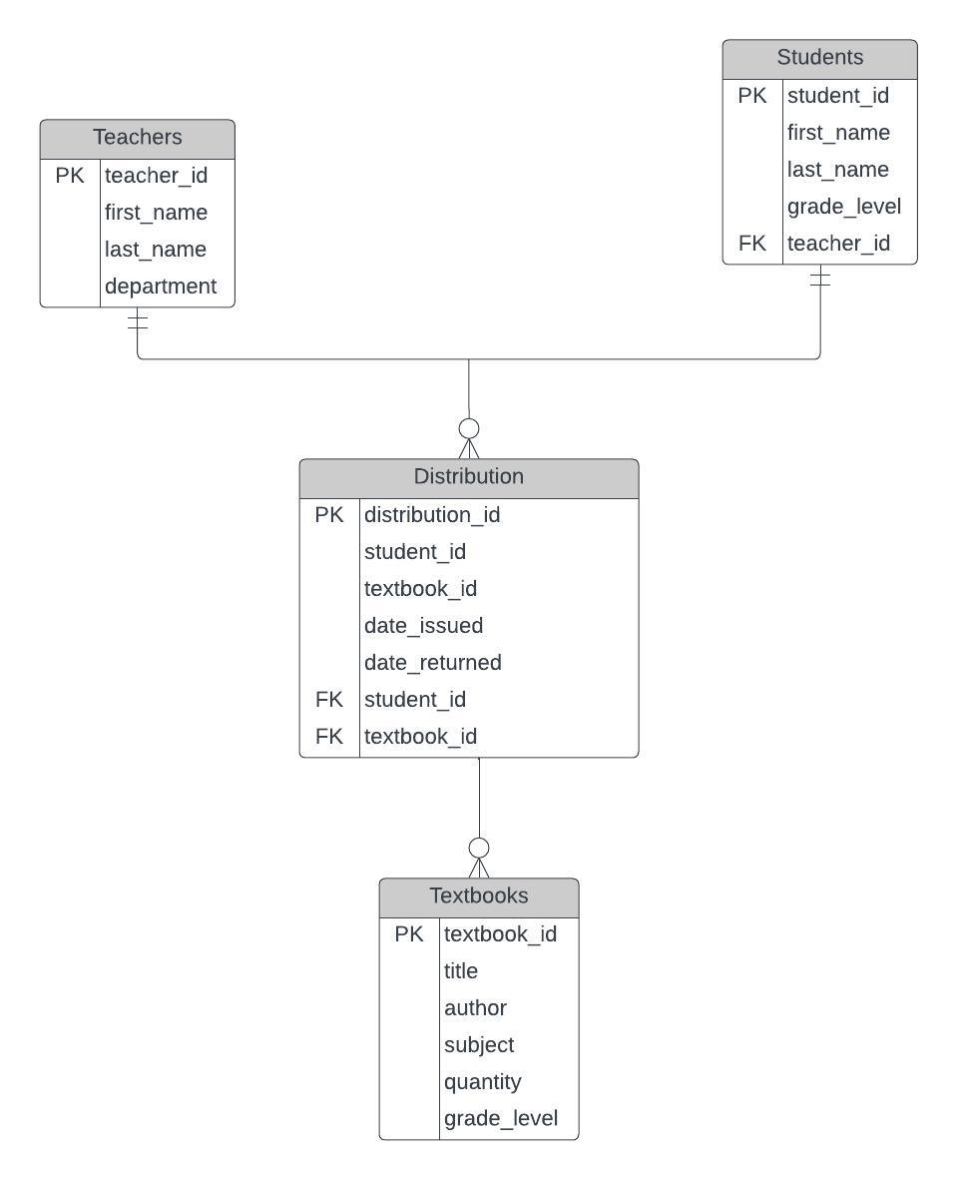

The ER diagram shows the different tables in the database and their relationships. The tables include Students, Teachers, Textbooks, and Distribution. The Students table stores information about the students in the school, including their name, grade level, and student ID. The Teachers table stores information about the teachers in the school, including their name and teacher ID. The Textbooks table stores information about the textbooks used in the school, including the title, author, and textbook ID. Finally, the Distribution table stores information about the textbook distribution to the students within the school, including the distribution ID, the student ID, the textbook ID, and the date issued and returned.

**NORMALIZATION OF THE DATABASE**

To ensure that the database is well-organized and easy to manage, I normalized the database into 3rd normal form. This involved breaking down entities into their most basic components and ensuring that each entity had only one primary key. The normalization process was as follows:

* First Normal Form (1NF): All attributes are atomic and do not contain any repeating groups or arrays.
* Second Normal Form (2NF): All non-key attributes are dependent on the primary key, and no partial dependencies exist.
* Third Normal Form (3NF): All non-key attributes are independent of each other, and no transitive dependencies exist.

**IMPLEMENTATION**

To show that the data is about 5-7 rows sample size, we can run the following SQL query:

**SELECT TOP 5 \***

**FROM Students;**

This query will return the first 5 rows in the Students table.

To demonstrate some queries that the database can handle, we can use the following examples:

1. **List all students in grade 3:**

**SELECT \***

**FROM Students**

**WHERE grade_level = '3';**

1. **Find a textbook assigned to a specific student:**

**SELECT Textbooks.\***

**FROM Textbooks**

**JOIN Distribution ON Textbooks.textbook_id = Distribution.textbook_id**

**JOIN Students ON Distribution.student_id = Students.student_id**

**WHERE Students.first_name = 'Sarah';**

1. **Retrieve the average quantity of textbooks per grade level:**

**SELECT grade_level, AVG(quantity)**

**FROM Textbooks**

**GROUP BY grade_level;**

1. **Retrieve the information of all textbooks that have a quantity greater than 10:**

**SELECT * FROM Textbooks WHERE quantity > 10;**

1. **Find the teacher for a specific student:**

**SELECT t.first_name, t.last_name**

**FROM Teachers t**

**JOIN Students s ON t.teacher_id = s.teacher_id**

**WHERE s.first_name = 'Tom' AND s.last_name = 'Ngatia';**

These examples demonstrate the flexibility of the database in handling various queries related to the distribution of textbooks in a primary school.

**Conclusion**

The AI run Text Book distribution system helps manage textbook distribution in primary schools. This system does all sorts of things, like storing information about students, teachers, textbooks, and the distribution, which makes it easier for school administrators to keep track of everything. Plus, it's designed to be free from redundancy and dependency issues, thanks to the ER diagram and normalization techniques used. This system can also handle all sorts of different queries related to textbook distribution in primary schools.

**References**

Asemi, A., Afshar, E., Eslami, M. R., & Haghparast, M. (2011, November 11). *A Review on Online System for Book Distribution in Developing Countries: A New Method*. ResearchGate. <https://www.researchgate.net/publication/321010678_A_Review_on_Online_System_for_Book_Distribution_in_Developing_Countries_A_New_Method>

*Book Publishers' Distribution Strategies*. (2020, September 17). Small Business - Chron.com. <https://smallbusiness.chron.com/book-publishers-distribution-strategies-76953.html>

Kalmykov, M. (2019, September 11). *8 Ways Artificial Intelligence Takes Publishing to the Next Level*. HackerNoon. <https://hackernoon.com/8-ways-artificial-intelligence-takes-publishing-to-the-next-level-rvnk3z3m>

Kubala-Chuchnowska, P., & Kubala-Chuchnowska, P. (2022, September 6). *The Role of Artificial Intelligence in the Publishing Industry*. State of Digital Publishing. <https://www.stateofdigitalpublishing.com/digital-platform-tools/ai-in-publishing-industry/>

P. (2023, March 16). *Book Distribution*. Luminare Press. <https://www.luminarepress.com/book-distribution/>

Payne, H. L. (2017, June 20). *Why Book Publishing Seeks Artificial Intelligence*. HuffPost. https://www.huffpost.com/entry/why-book-publishing-seeks-artificial-intelligence_b_59482841e4b0961faacbe5d6